SEASONS IN ANCIENT EGYPT
The Water Level of the Nile and its tributaries:
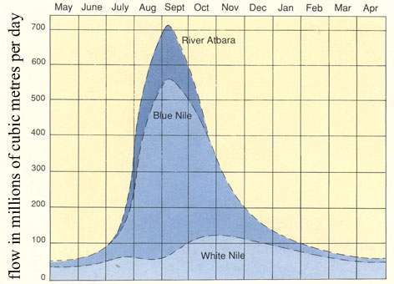
http://www.mbarron.net/Nile/fctfl_nf.html
MAIN CROPS AND ANIMALS
- Name the crops grown in Ancient Egypt.
- ______________ b. _______________
- Name the vegetables grown.
- _______________ d. ________________
- _______________ e. ________________
- _______________ f. ________________
- What animals did they have?
- _______________ e. _______________
- _______________ f. ________________
- _______________ g. ________________
- _______________ h . ________________
- What does the term “inundation” mean? _________________________________________ ____________________________________________________________________________________________________________________________________________________________________________________________________________________________________________________________________________________________________________
- When was inundation? ________________________________________________________

